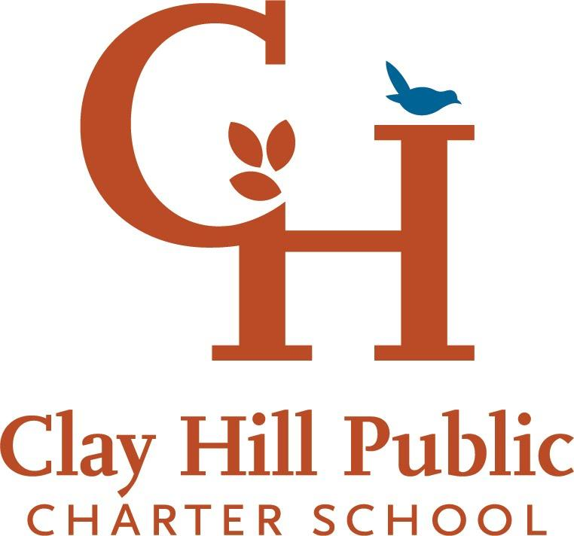
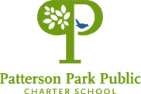

Job Application

The Mission of both Patterson Park Public Charter School and Clay Hill Public Charter School is to empower the school community - through a whole-child approach in a diverse, community-centered learning environment - to be stewards of an equitable future.
The Vision of Patterson Park Public Charter School and Clay Hill Public Charter School is to produce life-long learners, healthy families, and strong neighborhoods.

PPPCS and CHPCS are community-founded schools driven to academic excellence and devoted to a whole child philosophy in a diverse setting. At Patterson Park Public Charter School and Clay Hill Public Charter School, it is our privilege to serve a diverse community and our responsibility to foster inclusivity. We assert these values as the foundation for nurturing all of our students, realizing our mission and preparing our students for success in a global society.

NAME:

POSITION/S of INTEREST:

- PPPCS: Assistant Principal
- PPPCS: Instructional Assistant/Para Professional
- PPPCS: Early Childhood Teacher
- PPPCS: Elementary Teacher
- PPPCS: Middle School Teacher
- PPPCS: Special Education Teacher
- PPPCS: Middle School

- CHPCS: Curriculum Lead
- CHPCS: Kindergarten Teacher
- CHPCS: 1st Grade Teacher
- CHPCS: 2nd Grade Teacher
- CHPCS: Instructional Assistant/Para Professional
- CHPCS: Front Office Coordinator
- CHPCS: Social Worker
- CHPCS: .5 Media
- CHPCS: Special Educator/s
- CHPCS: ESOL Teacher/s
- CHPCS: Housekeeping

APPLICATION QUESTIONS: In lieu of a cover letter, we are asking all applicants to answer the following questions. Please limit your responses to 1-3 paragraphs per question.

- Tell us about your professional journey and why this is the right role for you at this time.

- PPPCS and CHPCS are committed to providing a whole-child education. What is your experience engaging in this educational philosophy? How did this manifest in your previous roles (ie: as a classroom teacher or other educational role)?

- PPPCS and CHPCS are committed to delivering an education with an equity lens in a diverse school community. What is your experience educating with an equity lens? How did this manifest in your previous roles (ie: as a classroom teacher or other educational role)?

